Synopsis
On
Modern Solution For Agricultural :
PROFARMER


Group ID: TYCORE209
Team Details
Enrolment No. | Name of Student | Class
ADT23SOCB0867 | ROHIT JAGTAP | TYCORE02
ADT23SOCB0919 | SAHIL KHANDAGALE | TYCORE02
ADT23SOCB0612 | MITHILESH BIRADAR | TYCORE02
ADT23SOCB1354 | YASH SONWANE | TYCORE02

Under the Guidance of
Prof. REVATI RASPAYLE

Department of Computer Science & Engineering
MIT School of Computing
Sem- 6 | A. Y. 2026-27

1. Title of the Project
“Pro-Farmer: A Digital Platform for Modern Agricultural Machinery Access and Subsidy Awareness”
2. Abstract (150–200 words)
Agriculture in India is rapidly moving toward modernization, but small and medium farmers still struggle to access advanced farming machinery due to limited market information, lack of verified suppliers, and low awareness of government subsidies. Traditional procurement methods involve visiting multiple wholesalers, comparing prices manually, and relying on local agents, which is time-consuming, costly, and often inaccurate. The proposed Pro-Farmer platform aims to solve these challenges by providing an online digital marketplace where farmers can browse, compare, and purchase agricultural equipment directly from verified wholesalers. This system provides real-time product availability, pricing, technical specifications, and subsidy information, allowing farmers to make informed purchasing decisions. Secure user authentication, reliable payment gateways, and order tracking ensure transparency and trust throughout the transaction. For wholesalers, Pro-Farmer provides an efficient digital dashboard to manage inventory, update listings, and reach a wider market without physical limitations. Thus, Pro-Farmer promotes mechanized farming, resource optimization, and cost efficiency, supporting both economic growth and sustainable agricultural practices. Overall, the platform enhances accessibility, increases subsidy utilization, and bridges the information gap between technology providers and farmers, leading to a more productive and digitally empowered agricultural ecosystem.
3. Introduction / Background
Agriculture plays a fundamental role in India’s economy, providing livelihood to millions of farmers across rural areas. However, despite technological advancements, modern agricultural machinery and tools are still not easily accessible to many farmers, especially those in remote regions. Traditional procurement processes require farmers to physically visit multiple equipment dealers, compare prices manually, and often depend on unverified local information or agents. This leads to delays, higher costs, limited choices, and lack of transparency. In addition, many farmers are unaware of the government subsidies, schemes, and support systems that can significantly reduce the cost of agricultural machinery.
With the rise of digitalization and e-commerce platforms, there is a growing opportunity to create smart solutions that bring modern tools, verified suppliers, and subsidy information directly to farmers in a convenient manner. Digital platforms can eliminate middlemen, increase transparency, reduce manual effort, and provide updated pricing and availability information instantly. The Pro-Farmer platform aims to bridge this gap by acting as a centralized, user-friendly marketplace where farmers can browse, compare, purchase, and gain awareness of modern equipment and government schemes.
By connecting farmers directly to wholesalers through a secure online system, Pro-Farmer not only simplifies the procurement process but also promotes digital agriculture, boosts farm productivity, and supports India’s vision of technologically empowered farming.

4. Problem Definition
Farmers struggle to access modern agricultural machinery due to lack of verified suppliers, limited market information, manual price comparison, and low awareness about government subsidies. Traditional offline procurement is time-consuming, expensive, and inefficient. There is no unified digital platform that offers real-time equipment availability, transparent pricing, and subsidy details. This leads to reduced productivity, delayed farming operations, and underutilization of modern farming technology. The problem is to develop a centralized digital system that connects farmers with verified wholesalers, displays accurate product/subsidy information, and enables secure online equipment procurement.
5. Objectives
The main objective of the Pro-Farmer platform is to simplify and digitize the process of accessing modern agricultural machinery and subsidy information for farmers. The specific objectives are as follows:
- To provide farmers with a centralized online platform to browse, compare, and purchase agricultural equipment from verified wholesalers.
- To increase awareness about government subsidies related to farming machinery and make subsidy information easily accessible and understandable.
- To reduce dependency on middlemen and physical visits by enabling online equipment procurement through a secure and user-friendly interface.
- To promote digital agriculture and mechanization, helping farmers adopt modern farming tools to increase productivity and operational efficiency.
- To ensure transparency in pricing, product details, and supplier information, enabling farmers to make accurate and informed purchasing decisions.
- To offer wholesalers an organized digital dashboard to manage listings, inventory, and track user demand efficiently.
- To support cashless and secure digital payments, reducing manual transactions and improving transactional safety.
- To contribute toward sustainable and smart farming practices through technology-driven solutions that optimize resource usage and reduce time and effort for farmers.

6. Scope of the Project
The scope of the Pro-Farmer project is to develop an online platform that connects farmers directly with verified agricultural machinery suppliers. The system allows farmers to view available equipment, compare prices, check subsidy information, and purchase products through secure digital payments. It includes modules for user registration, product listings, real-time inventory updates, order placement, and notification alerts. The platform also provides wholesalers with tools for managing inventory and product details. Future scope includes adding mobile app support, AI-based recommendations, and integration with government portals.
7. Proposed System
The proposed Pro-Farmer system is a centralized digital platform where farmers can directly access modern agricultural machinery, compare prices, view government subsidy details, and purchase equipment online. The system removes the need for physical visits and intermediaries by offering a complete online marketplace specifically designed for farming equipment.
The platform consists of two main roles — Farmer Users and Wholesalers/Suppliers.
Farmers can browse equipment, apply filters, read specifications, check subsidy eligibility, and place orders using secure digital payments. Wholesalers can upload equipment details, maintain inventory, manage incoming orders, and respond to demand through their dashboard.
The system backend manages all product, user, transaction, and subsidy data. It also integrates with payment gateways for digital transactions and links to subsidy databases for proper information. This ensures real-time availability, transparency, and trust. The platform is designed to be scalable, secure, and user-friendly, enabling even small farmers in rural areas to adopt mechanized farming at affordable prices.

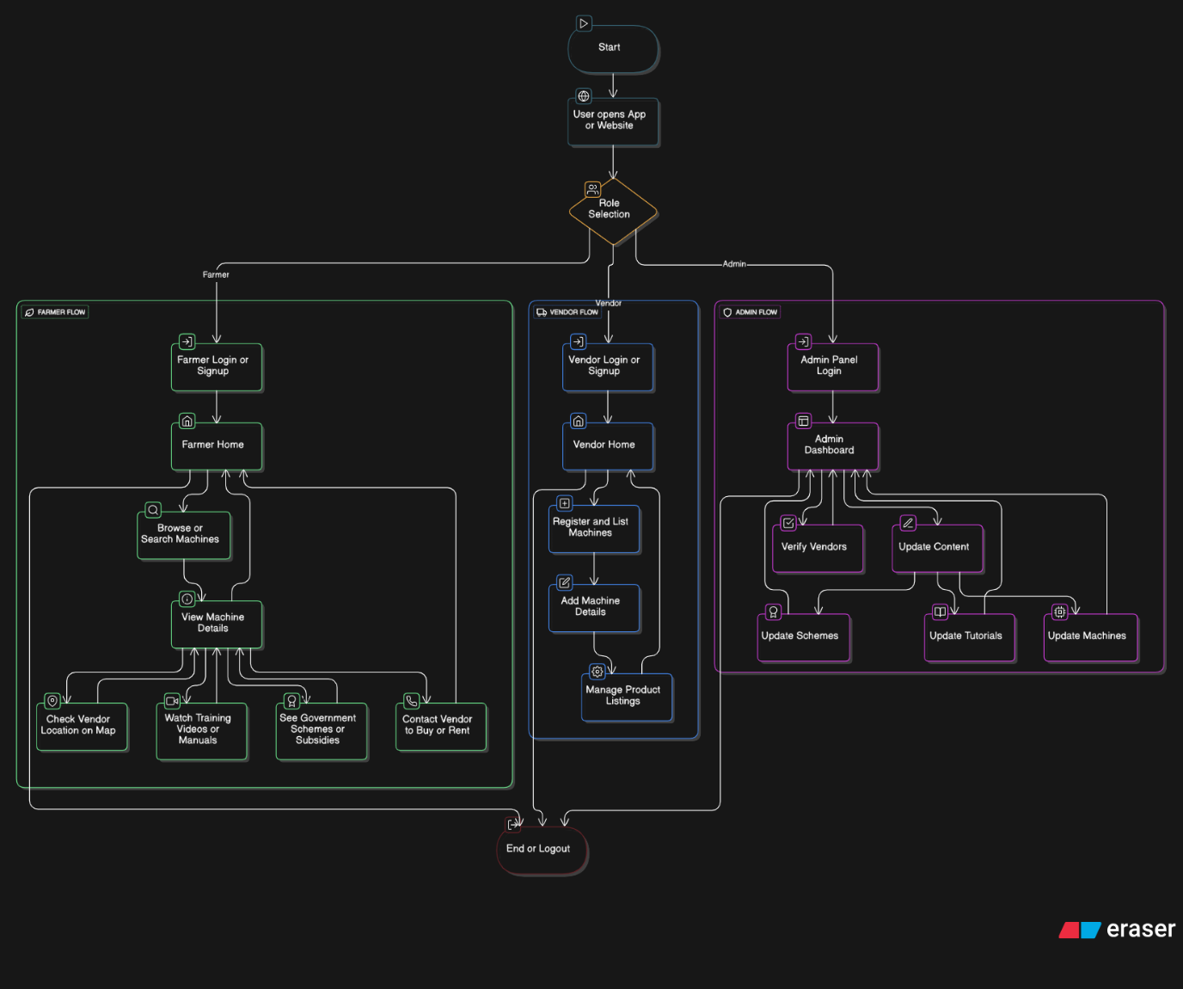

Figure: Block Diagram of the Architecture
8. System Requirements
a. Hardware Requirements
- Computer/Laptop with minimum Intel i3 Processor
- Minimum 4 GB RAM (8 GB recommended)
- Minimum 250 GB Storage
- Stable Internet Connection
- Smartphone for Farmers (Android recommended)
- Cloud Server for Hosting (2 GB RAM Minimum)
b. Software Requirements
- Operating System: Windows / Linux / macOS
- Frontend: HTML, CSS, JavaScript, React.js
- Backend: Node.js + Express.js
- Database: MongoDB / MySQL
- IDE / Editor: VS Code
- Version Control: Git / GitHub
- Payment Integration: Razorpay / Paytm API

9. Methodology / Implementation Plan (Project Tracker Sheet)
- Requirement Analysis
  - Identify farmer needs, subsidy sources, and equipment supplier requirements.
- System Design
  - Design UI screens, database structure, and overall architecture of the platform.
- Frontend Development
  - Create user interface using HTML, CSS, JavaScript, React.js.
- Backend Development
  - Develop APIs using Node.js and Express.js for login, products, payments, etc.
- Database Integration
  - Create collections/tables for farmers, suppliers, equipment, orders, subsidies.
- Payment & Notification Setup
  - Integrate online payment gateway and enable email/SMS notifications.
- Testing
  - Functional testing, API testing, UI testing, and user acceptance testing.
- Deployment
  - Host the system on cloud server and make it accessible to farmers and suppliers.
- Maintenance & Updates
  - Fix bugs, upgrade features, and improve system based on user feedback.
10. Expected Outcome
- Farmers will be able to easily view, compare, and purchase modern farming machinery online.
- Awareness and usage of government subsidies for agricultural equipment will increase.
- Procurement of farming tools will become faster, transparent, and more cost-efficient.
- Wholesalers will get a digital platform to reach more customers and manage inventory easily.
- Overall productivity of farming operations will improve through better mechanization.
11. Applications / Use Cases
- Farmers can view, compare, and purchase agricultural machinery online.
- Farmers can check government subsidy details before buying equipment.
- Wholesalers can upload machinery details, manage stock, and receive online orders.
- Digital payments can be used for secure and fast transactions between farmers and sellers.
- The platform can be used by government/NGOs to spread awareness of schemes and modern farming tools.
- Can be used by rural farming groups, co-operatives, and agri-dealers to promote mechanized farming.
12. Future Enhancements/ Future Scope
- Launch dedicated mobile app for Android & iOS for easier farmer access.
- Add AI-based recommendation system to suggest best equipment based on crop type and land size.
- Integrate directly with government subsidy portals for automatic subsidy updates.
- Add voice assistance and regional language support for less technical users.
- Enable equipment rental/sharing platform between farmers to reduce cost.
- Add review & rating system for wholesalers and equipment quality verification.
- Integrate IoT-based machinery monitoring and smart alerts for maintenance and usage tracking.
13. References
- Farmer Equipment Supply and Awareness Platform (IJSRD, 2023): Presents a web-based system connecting farmers with agricultural equipment suppliers and providing access to subsidy information.
- Smart Farming Equipment Management System (IJARSCT, 2024): Discusses digital solutions for managing agricultural machinery sales, rentals, and online farmer support systems.
- Agricultural Marketplace and Mechanization Portal (JETIR, 2024): Analyzes an online marketplace that connects farmers with equipment manufacturers and wholesalers to promote mechanized farming.
- AI-Based Smart Agriculture and Equipment Recommendation System (IJFMR, 2025): Introduces AI-driven solutions for matching farmers with suitable agricultural machines based on crop type and farm size.
- Bridging the Gap Between Farmers and Technology (Times of India, 2024): Highlights how digital platforms and startups are transforming Indian agriculture through innovation and modern equipment accessibility.

